RPG miniatures template for 25mm scale
Based on D&D 5.5 2024 "Heroes of the Borderlands" starter set pregenerated characters, plus SRD playable species, plus common monsters.
35mm = 7' ; Human / Elf 5'4-6'2 = 26-31mm 1' = 5mm
 |  |  |  |  |  |  |  | Base
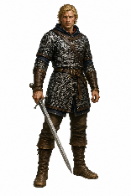 | 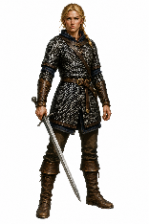 | 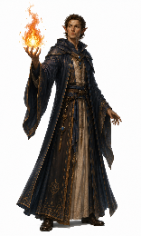 | 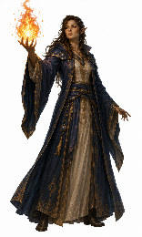 | 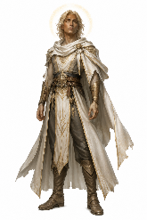 | 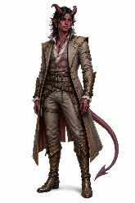 | 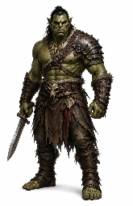 | 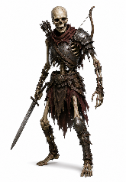 | Upside down image
 |  |  |  |  |  |  |  | Rightside up image
Human  Fighter M | Human  Fighter F | Elf  Wizard M | Elf  Wizard F | Aasimar | Tiefling | Orc | Skeleton | Base
 |  |  |  |  |  |  |  | Base
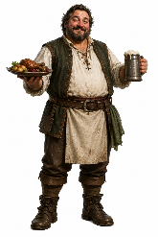 | 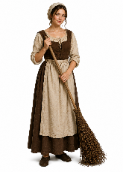 | 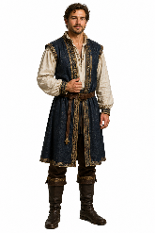 | 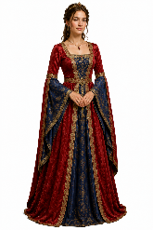 | 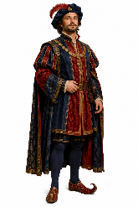 | 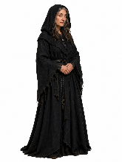 | 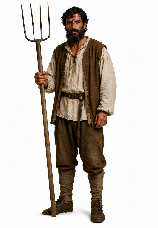 | 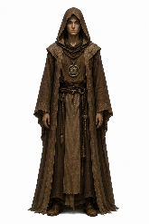 | Upside down image
 |  |  |  |  |  |  |  | Rightside up image
Innkeeper | Maid | Gentleman | Lady | Nobleman | Crone | Peasant | Monk | Base

Fold base like so, and tape at base. Initially, allow top point to curve rather than fold.
Allow the base to "hinge" inwards for flat storage. Fold top point only when base is folded in and flattened.
If using card, score lightly along lines at base, but not top.
Designed by Andrew Oakley 2026 public domain aoakley.com
Pictures generated using ChatGPT from original prompts by Andrew Oakley
RPG miniatures template for 25mm scale
40mm = 8' ; Goliath / Ogre 7'-7'6 = 35-38mm 25mm = 5' ; Dwarf 4-5' = 20-25mm ; Halfling 3' = 15mm ; Dog 1'6-2' = 7-10mm
 |  |  |  |  |  |  |  | Base
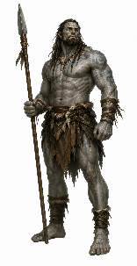 | 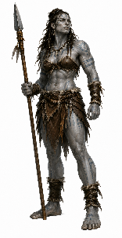 | 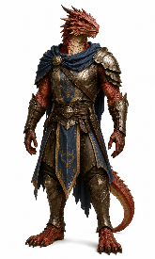 | 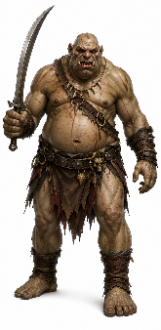 | 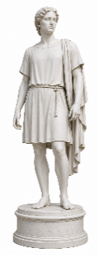 | 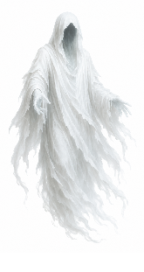 | 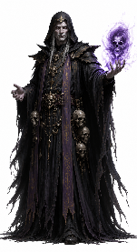 | 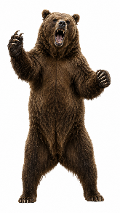 | Upside down image
 |  |  |  |  |  |  |  | Rightside up image
Goliath  Barbarian M | Goliath  Barbarian F | Dragonborn | Ogre | Statue | Ghost | Necromancer | Bear | Base
 |  |  |  |  |  |  |  | Base
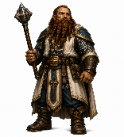 | 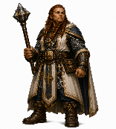 | 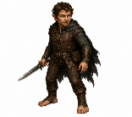 | 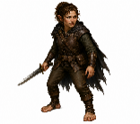 | 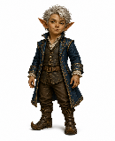 | 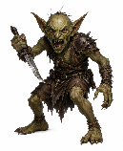 | 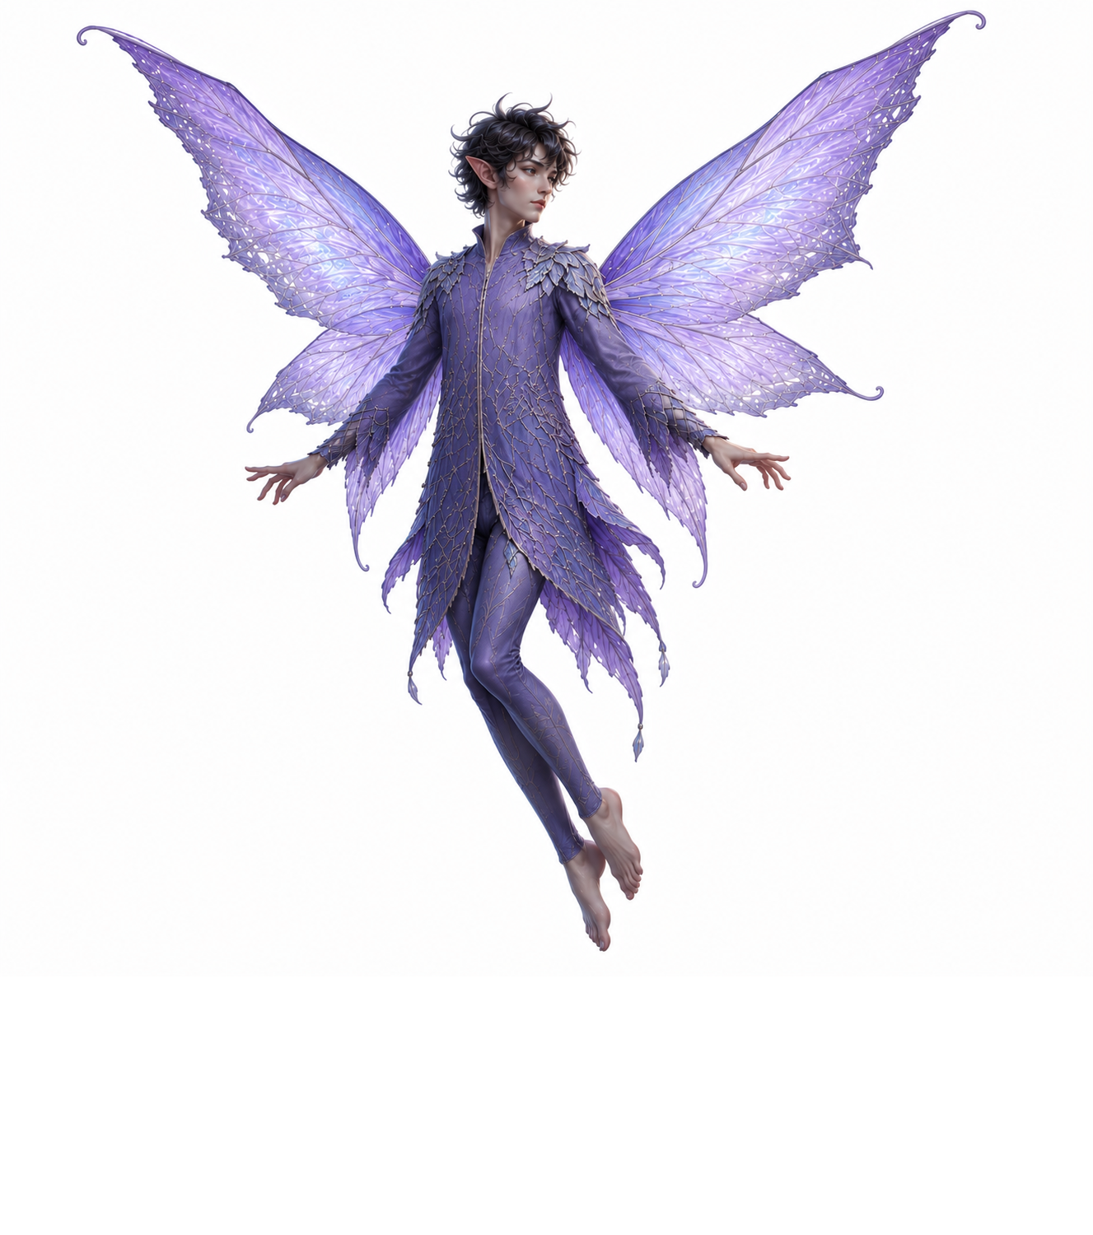 | 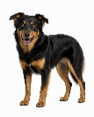 | Upside down image
 |  |  |  |  |  |  |  | Rightside up image
Dwarf  Cleric M | Dwarf  Cleric F | Halfling  Rogue M | Halfling  Rogue F | Gnome | Goblin | Fairy | Dog | Base

Fold base like so, and tape at base. Initially, allow top point to curve rather than fold.
Allow the base to "hinge" inwards for flat storage. Fold top point only when base is folded in and flattened.
If using card, score lightly along lines at base, but not top.
Designed by Andrew Oakley 2026 public domain aoakley.com
Pictures generated using ChatGPT from original prompts by Andrew Oakley
Why only white, northern European models? I am from an isolated rural area with little experience of other ethnicities. I am concerned that my attempts might be stereotypes. Please, please adapt this template with your own characters. The ChatGPT prompts I used were "In the context of Dungeons & Dragons, create a picture of [your choice] on a white background and [desired] aspect ratio". Consider adding "with [desired ethnicity] heritage". Aspect ratios are: Human/Elf 18:27, Goliath 18:35, Dwarf 18:23, Halfling 18:15.

Human-sized monsters and NPCs 18:27 aspect ratio (deliberately some duplicates)
 |  |  |  |  |  |  |  | Base
 |  |  |  |  | 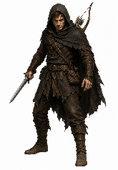 |  |  | Upside down image
 |  |  |  |  |  |  |  | Rightside up image
Orc | Orc | Skeleton | Skeleton | Skeleton | Bandit | Bandit | Bandit | Base
 |  |  |  |  |  |  |  | Base
 |  | 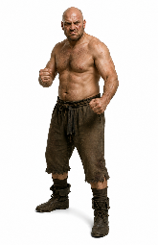 | 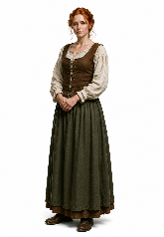 |  |  |  |  | Upside down image
 |  |  |  |  |  |  |  | Rightside up image
Gentleman | Gentleman | Brawler | Town woman | Crone | Peasant | Monk | Monk | Base

Large and small creatures (deliberately some duplicates)
 |  |  |  |  |  |  |  | Base
 |  |  | 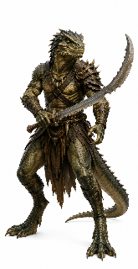 |  | 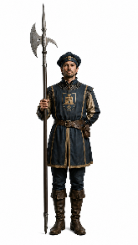 |  |  | Upside down image
 |  |  |  |  |  |  |  | Rightside up image
Ogre | Ghost | Ghost | Lizardfolk | Lizardfolk | Guard | Guard | Guard | Base
 |  |  |  |  |  |  |  | Base
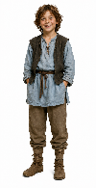 |  |  |  | 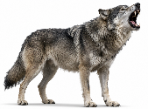 |  | 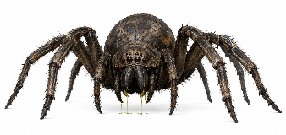 |  | Upside down image
 |  |  |  |  |  |  |  | Rightside up image
Child | Goblin | Goblin | Goblin | Wolf | Wolf | Giant Spider |  | Base

